**THE TRAGEDY OF FLIGHT: THE COMPREHENSIVE**

**CRASH ANALYSIS**

**Introduction**

**Overview**

An airplane crash analysis is a detailed investigation into the causes of an aviation accident. The goal of an airplane crash analysis is to identify any factors that contributed to the accident, with the ultimate goal of improving safety and preventing future accidents. The process of conducting an airplane crash analysis typically involves the collection and analysis of a wide range of data, including information about the aircraft and its systems, the operators, and any other relevant factors. This data is typically collected from Kaggle. Once the data has been collected, it is analysed through tableau, to identify any potential causes of the accident. The results of an airplane crash analysis are typically published in a report, which may include recommendations for improving safety and preventing similar accidents in the future. These recommendations may be implemented by the relevant authorities or industry organizations.

**Purpose**

* Understanding the causes of plane accidents can help improve aviation safety by identifying areas where improvements can be made in the design, operation, and maintenance of aircraft.
* Learning about plane accidents can also help passengers and crew members prepare for emergencies by understanding the potential risks and how to respond in case of an emergency.
* Investigating plane accidents is essential for determining the cause of the accident, preventing future accidents, and providing closure to the families of those affected.
* Understanding the causes of plane accidents is critical in improving aviation safety. Causes can include human error, technical problems, weather conditions, or a combination of factors.
* Investigating plane accidents involves analyzing the data, reconstructing the sequence of events, and identifying the root causes of the accident.

**Problem definition & design thinking**

**Empathy map**

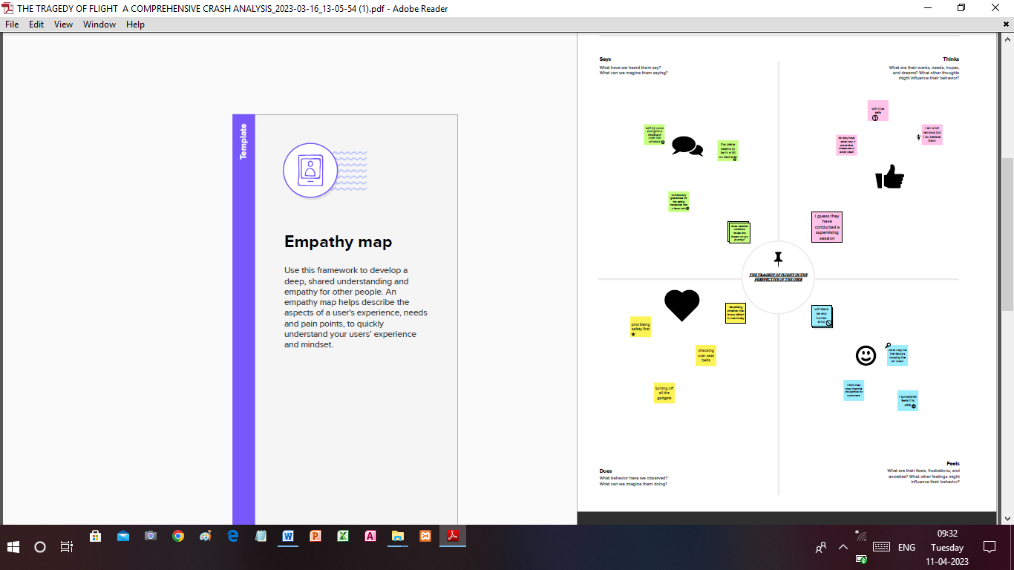

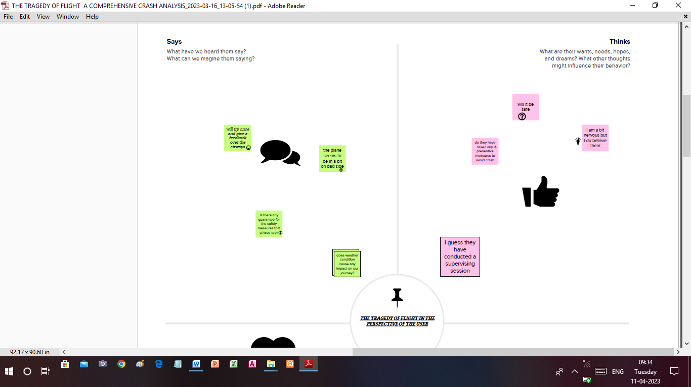

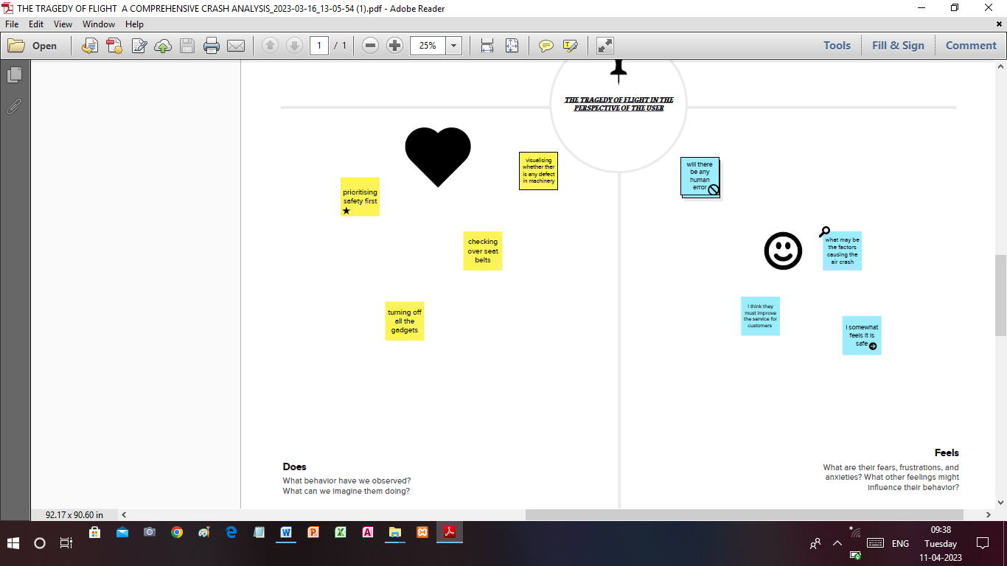

**Ideation &Brainstroming map**

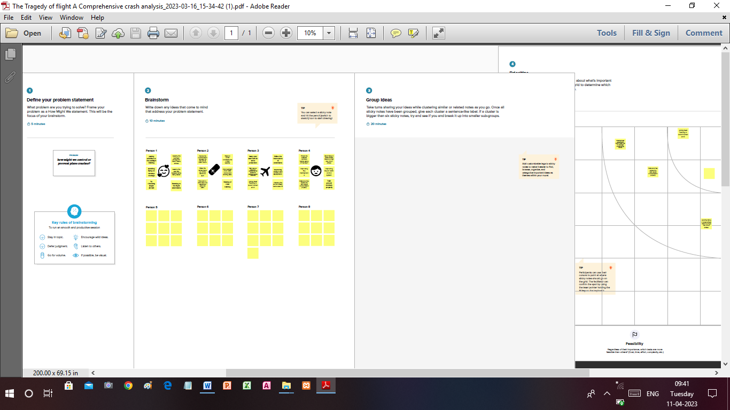

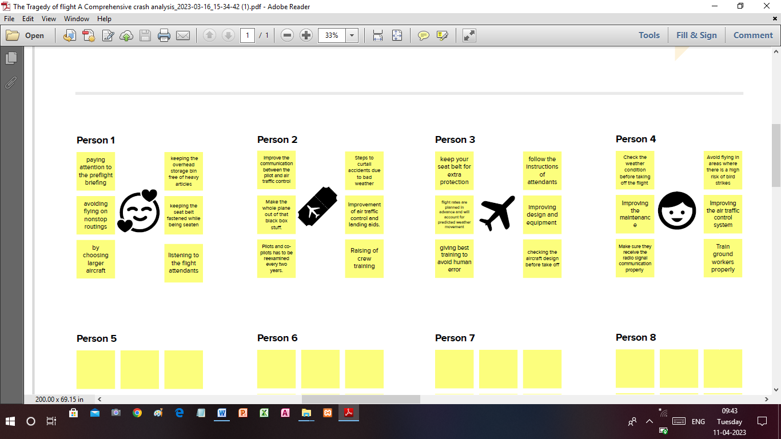

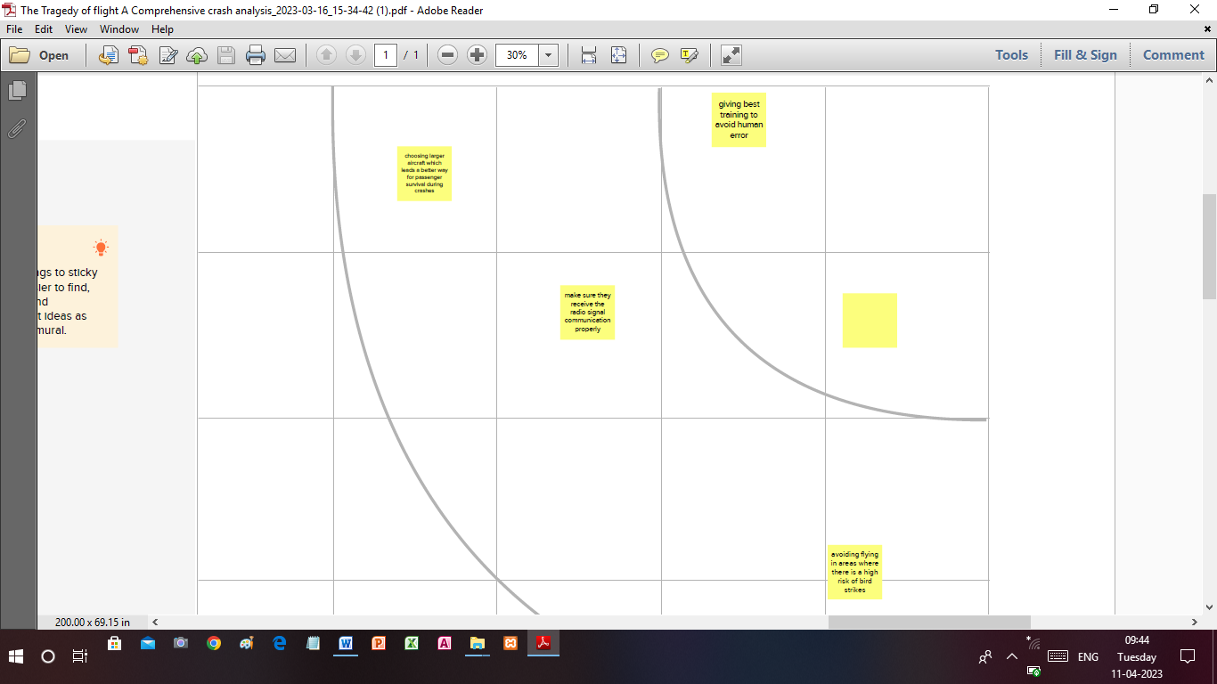

**Result**

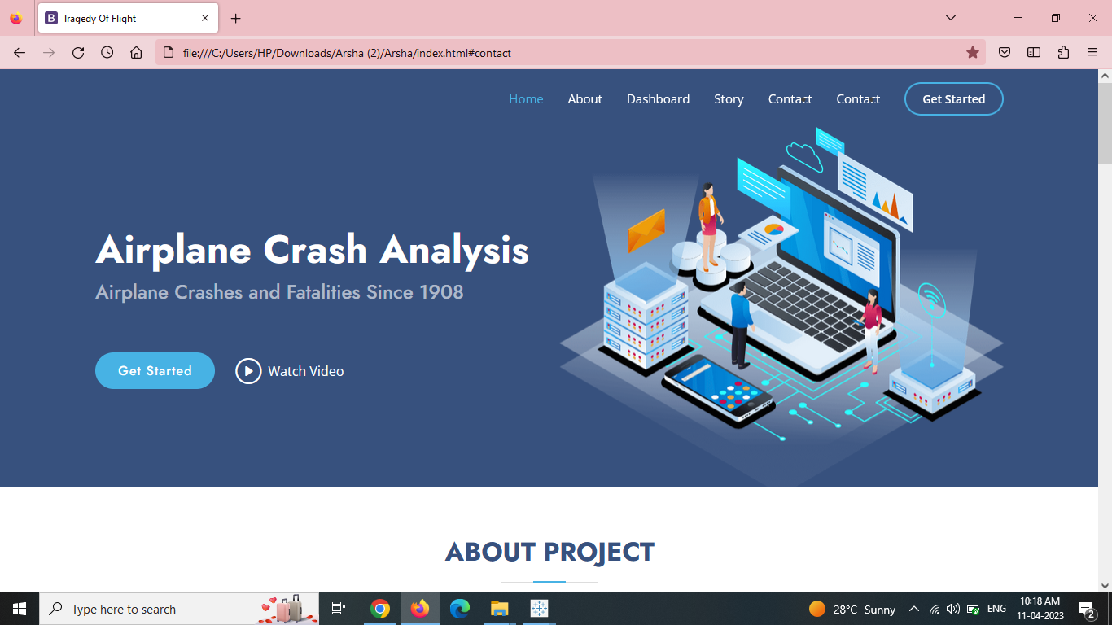

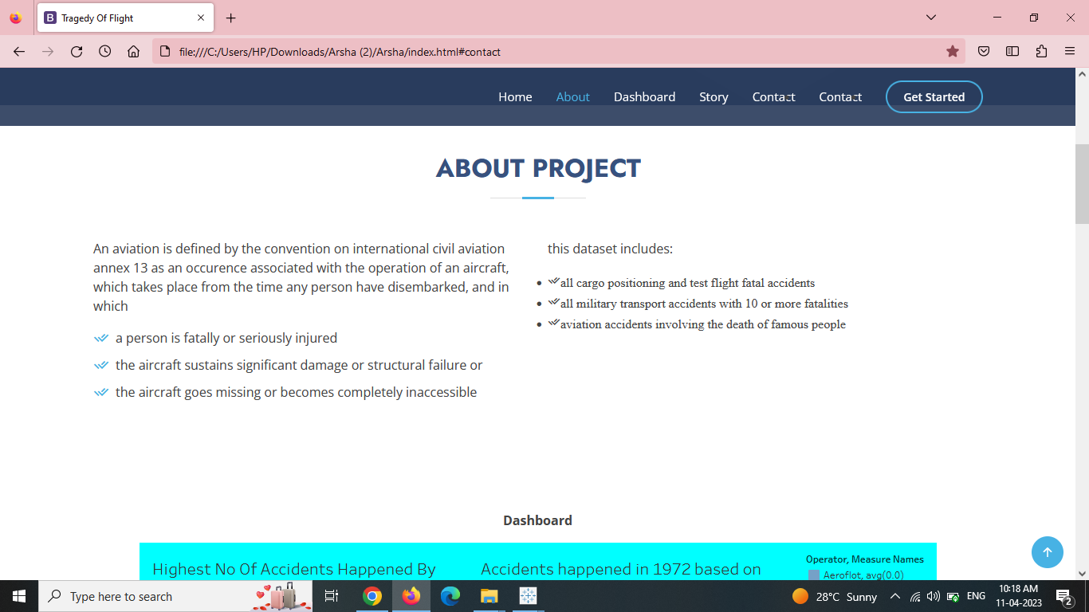

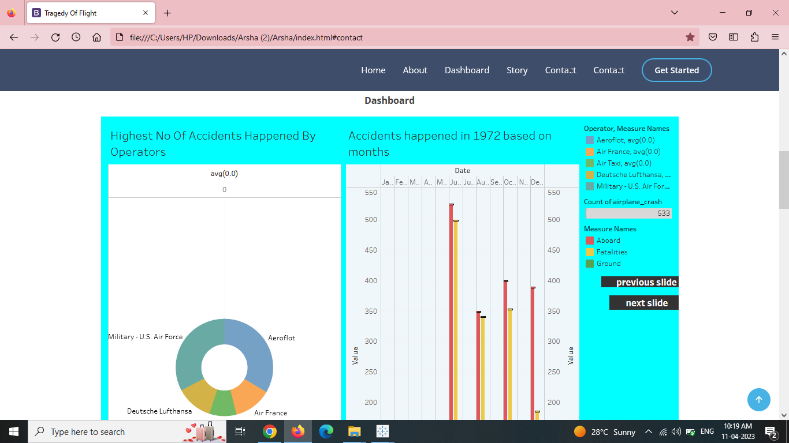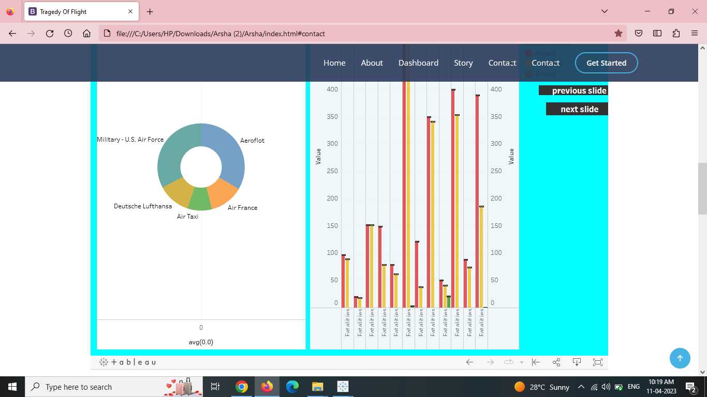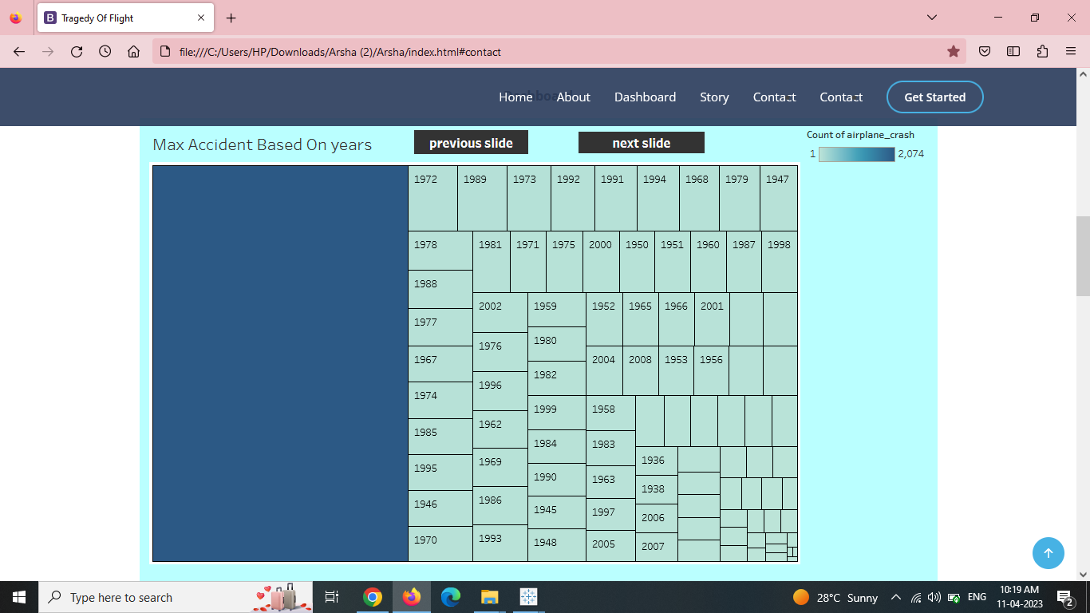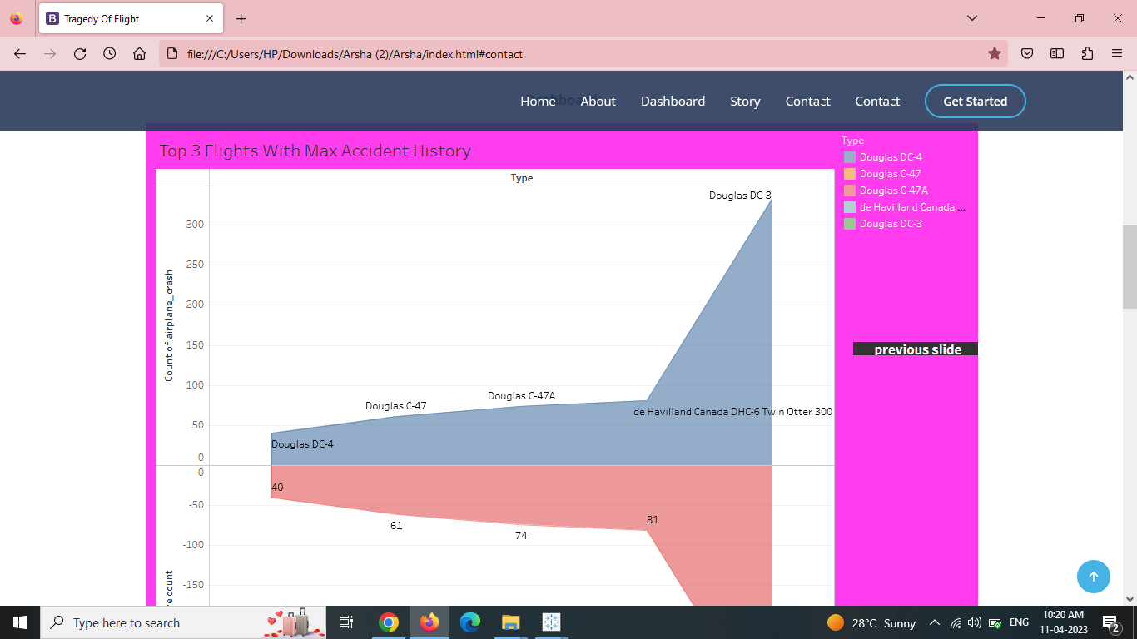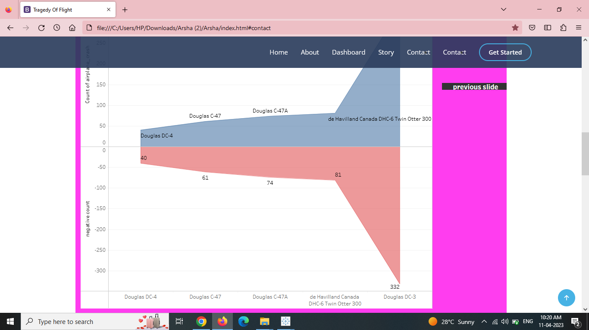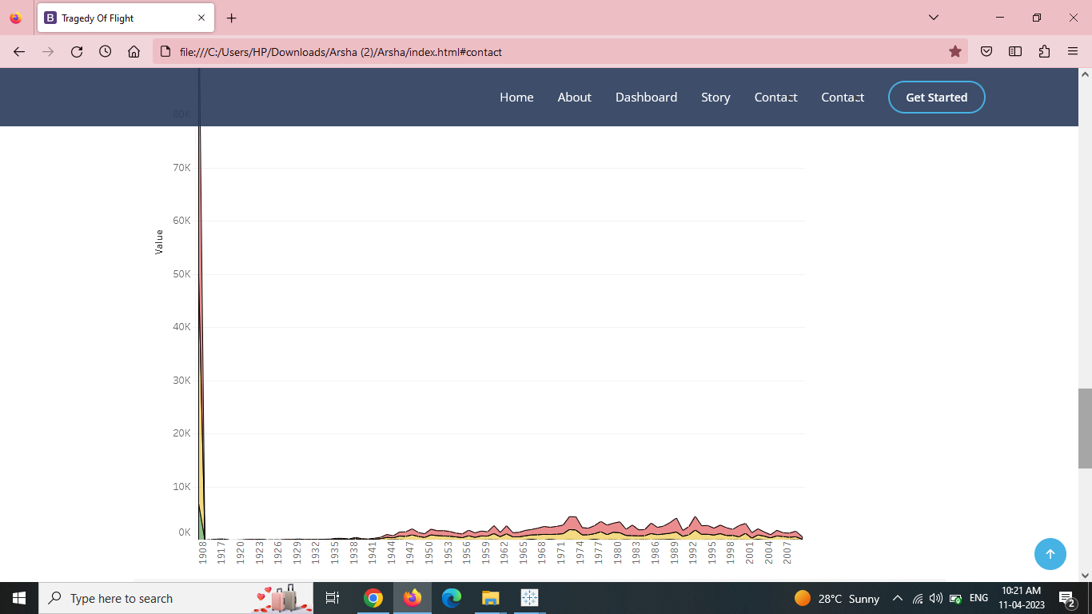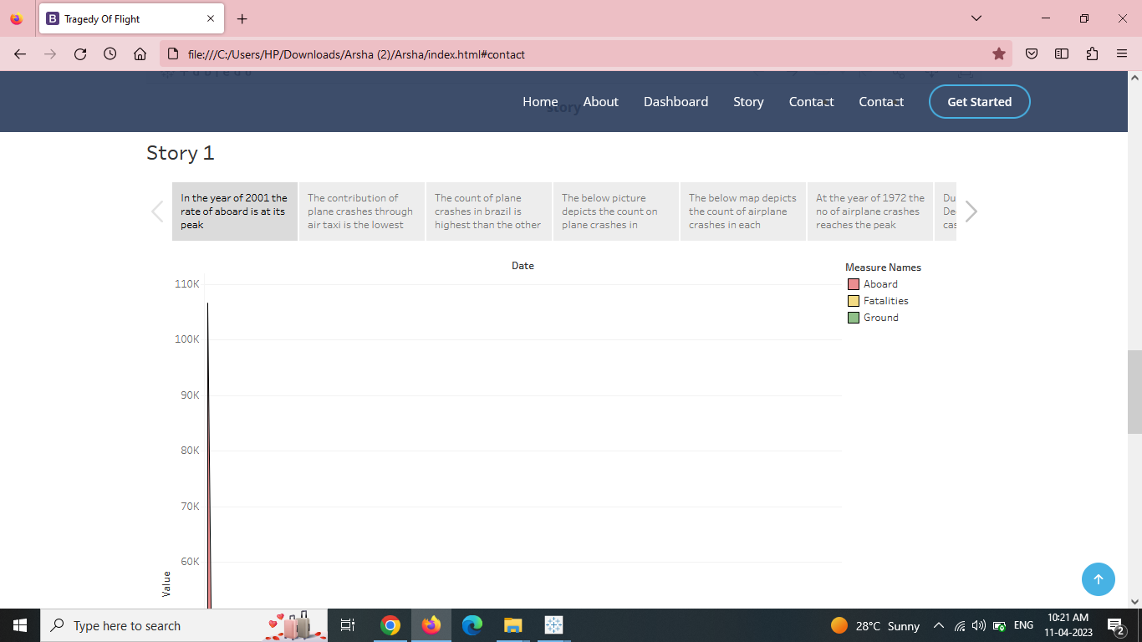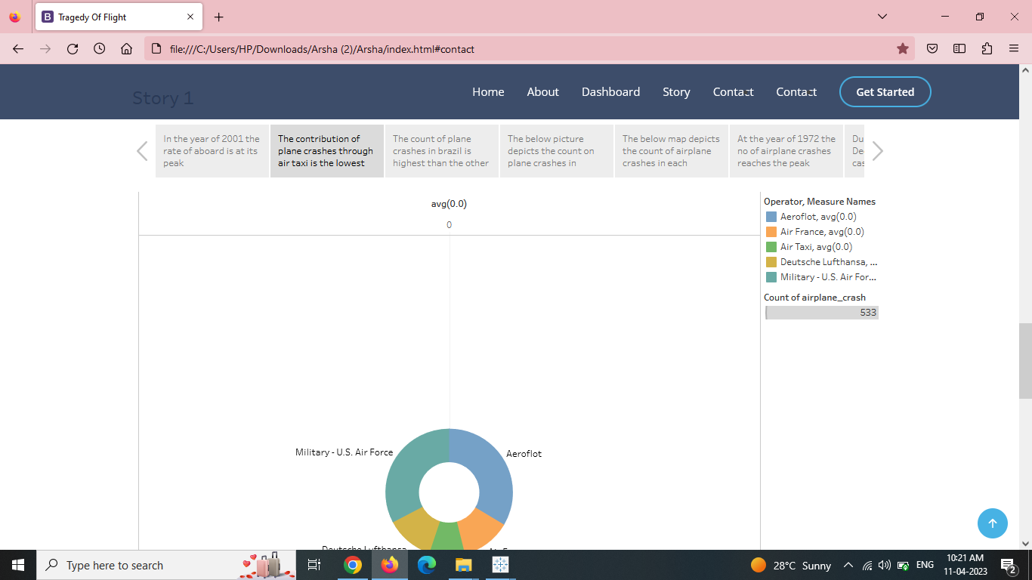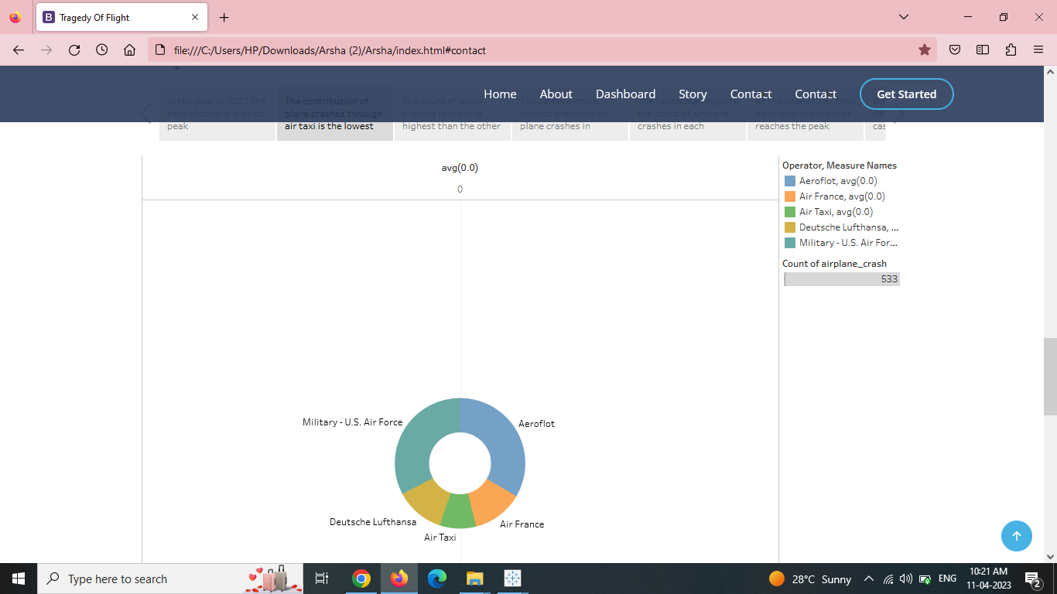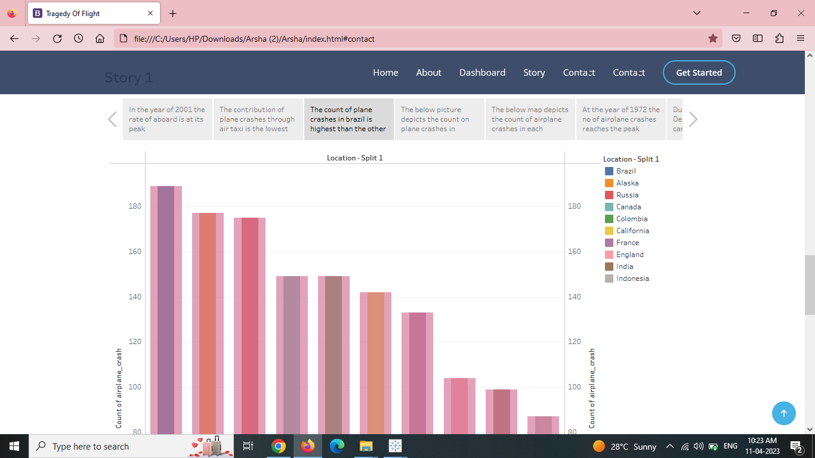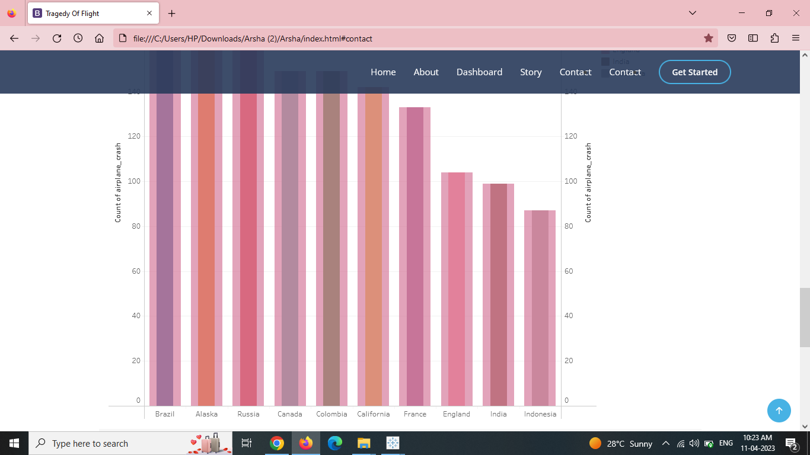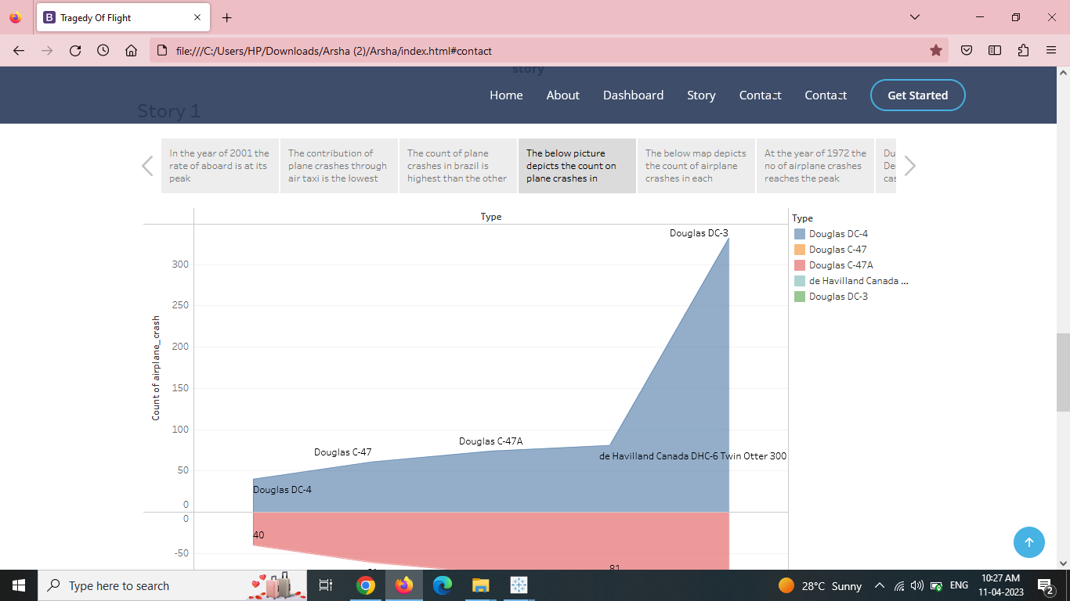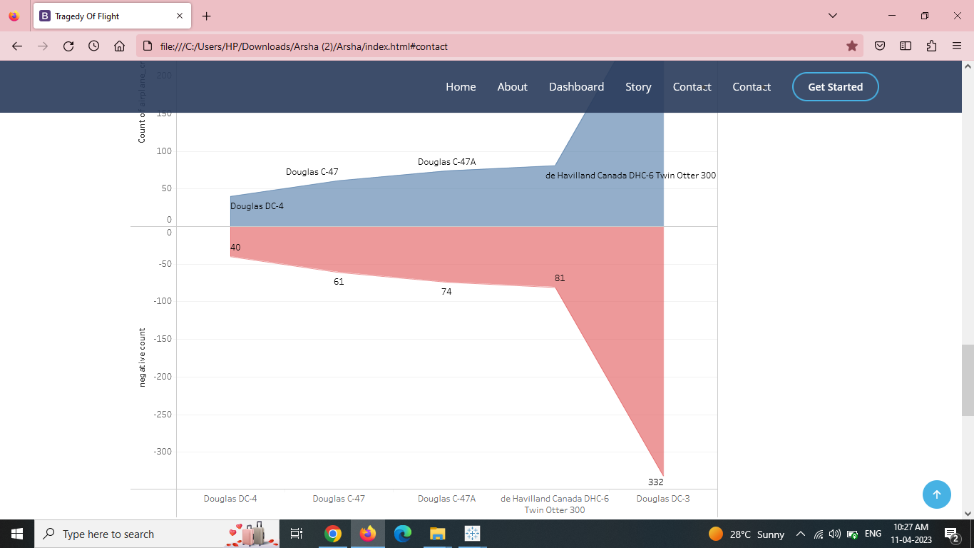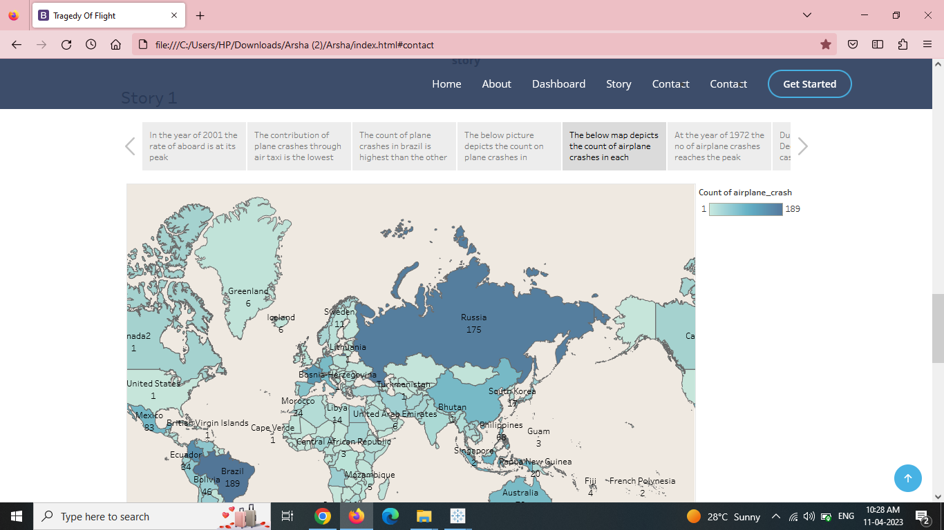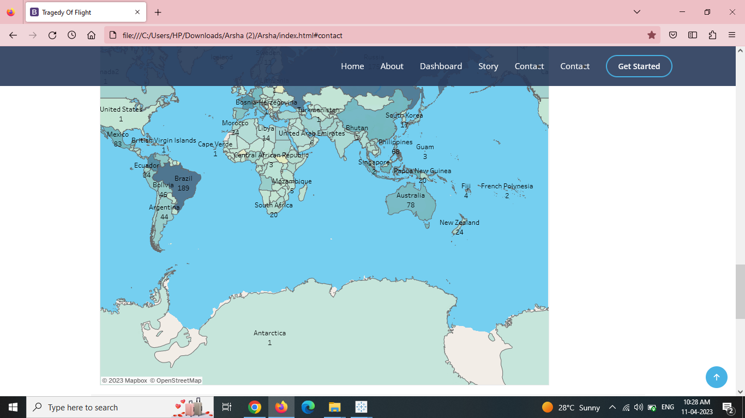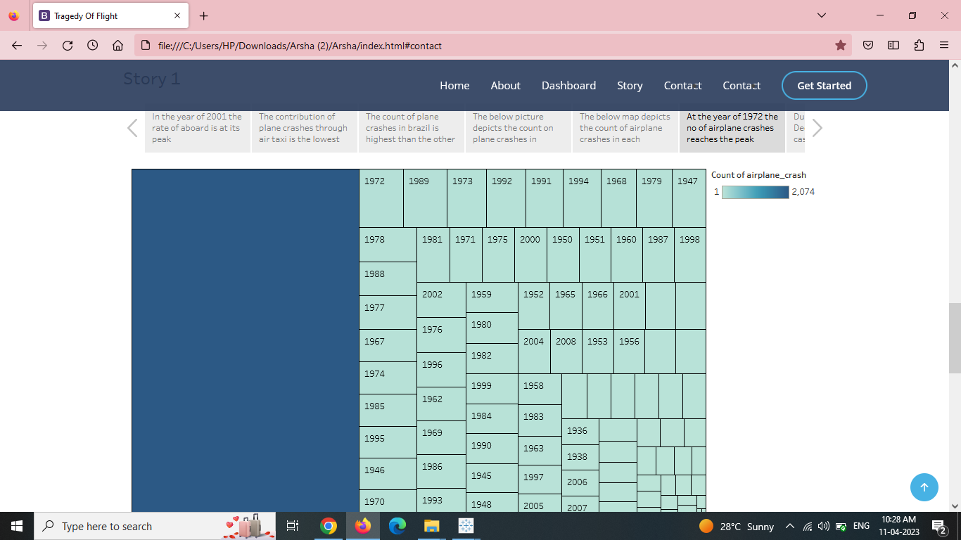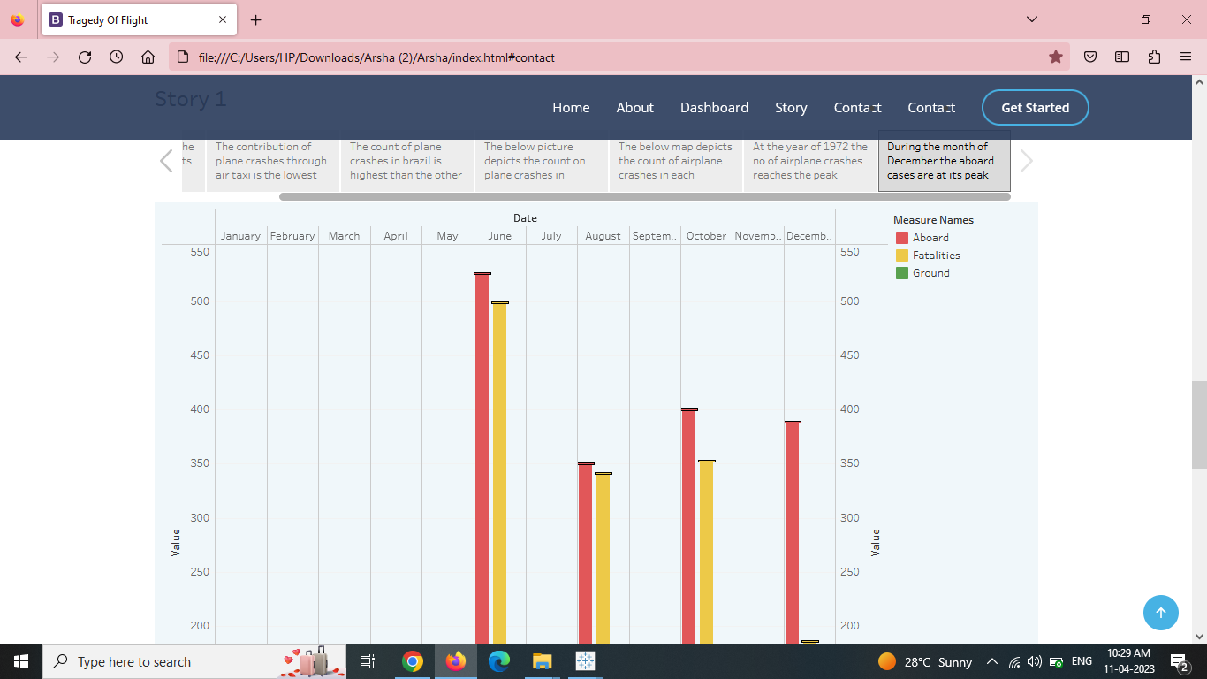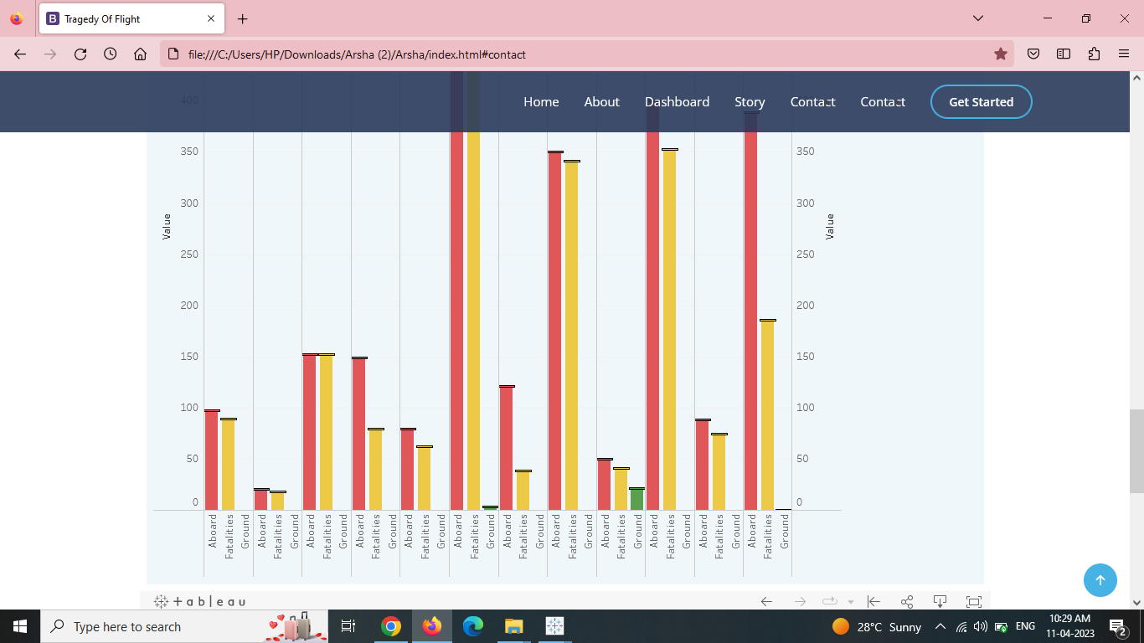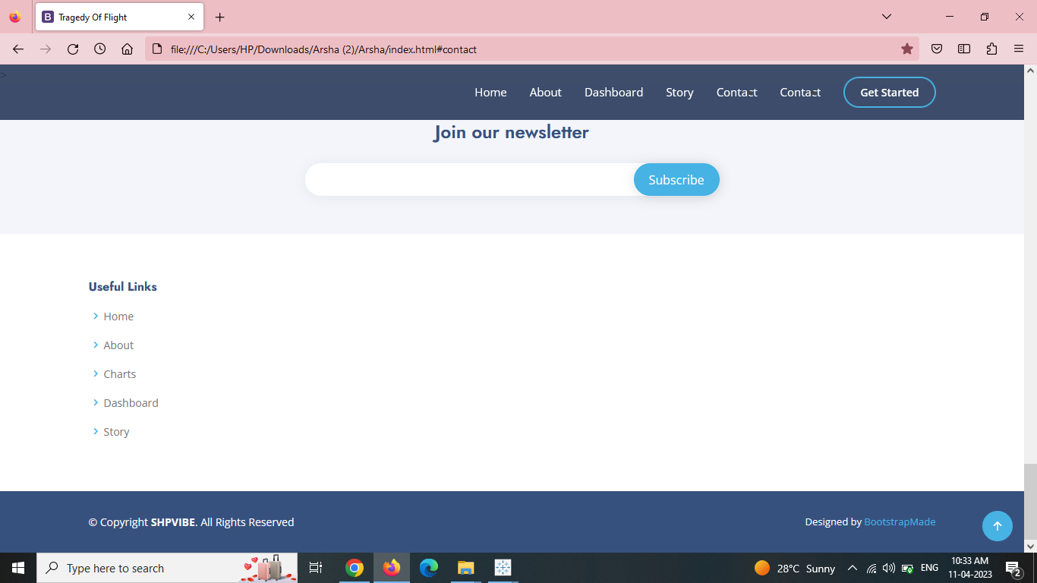

**Advantages**

* Make the whole plane out of that black box stuff.
* Improve the communication between the pilot and air traffic control
* Giving best training to avoid human error
* Once crash of plane occurs we can reduce this type of problem in future
* Improving design and equipment. It will increase the plane quality

**Disadvantages**

* It happens 90 percentage of human error
* Loss of life: One of the most devastating disadvantages of airplane accidents is the loss of human life
* Physical injuries: Survivors of airplane accidents may suffer physical injuries such as burns, broken bones, spinal cord injuries, or head injuries. These injuries may lead to long-term disabilities or impairments.
* Post-traumatic stress disorder (PTSD) and anxiety are common psychological reactions to traumatic events like airplane accidents.
* Damage to property: Airplane accidents can also cause significant damage to property, including buildings, vehicles, and natural environments. This damage can result in costly repairs and a long recovery process for affected communities.

**Conclusion**

Overall, airplane accidents can have devastating consequences for individuals, families, and entire communities. It is essential to prioritize safety and implement effective measures to prevent such accidents from occurring.Plane accidents can provide valuable lessons for improving air safety and preventing similar incidents from happening in the future. Preventing plane accidents requires a culture of safety in which everyone involved in flight operations is committed to prioritizing safety above all else. Overall, learning about plane accidents is essential for improving aviation safety, preparing for emergencies, and ensuring effective response and investigation in case of an accident.

**Future scope**

* Planes can also be made safer by incorporating advanced technologies like autonomous systems, better sensors, and more reliable communication systems. These features can help reduce accidents and increase passenger confidence.
* Advanced avionics systems can improve flight operations, reduce the workload on pilots, and enhance overall safety.
* These systems can include features like enhanced navigation tools, real-time weather information, and automatic collision avoidance systems.
* Improving the passenger experience is also essential, and planes can be designed with greater passenger comfort and convenience in mind.
* This can include features like more spacious seating arrangements, advanced in-flight entertainment systems, and improved amenities like food and beverage services.

**Appendix**

**Source code**

<!DOCTYPE html>

<html lang="en">

<head>

  <meta charset="utf-8">

  <meta content="width=device-width, initial-scale=1.0" name="viewport">

  <title>Tragedy Of Flight</title>

  <meta content="" name="description">

  <meta content="" name="keywords">

  <!-- Favicons -->

  <link href="assets/img/favicon.png" rel="icon">

  <link href="assets/img/apple-touch-icon.png" rel="apple-touch-icon">

  <!-- Google Fonts -->

  <link href="https://fonts.googleapis.com/css?family=Open+Sans:300,300i,400,400i,600,600i,700,700i|Jost:300,300i,400,400i,500,500i,600,600i,700,700i|Poppins:300,300i,400,400i,500,500i,600,600i,700,700i" rel="stylesheet">

  <!-- Vendor CSS Files -->

  <link href="assets/vendor/aos/aos.css" rel="stylesheet">

  <link href="assets/vendor/bootstrap/css/bootstrap.min.css" rel="stylesheet">

  <link href="assets/vendor/bootstrap-icons/bootstrap-icons.css" rel="stylesheet">

  <link href="assets/vendor/boxicons/css/boxicons.min.css" rel="stylesheet">

  <link href="assets/vendor/glightbox/css/glightbox.min.css" rel="stylesheet">

  <link href="assets/vendor/remixicon/remixicon.css" rel="stylesheet">

  <link href="assets/vendor/swiper/swiper-bundle.min.css" rel="stylesheet">

  <!-- Template Main CSS File -->

  <link href="assets/css/style.css" rel="stylesheet">

  <!-- =======================================================

  * Template Name: Arsha

  * Updated: Mar 10 2023 with Bootstrap v5.2.3

  * Template URL: https://bootstrapmade.com/arsha-free-bootstrap-html-template-corporate/

  * Author: BootstrapMade.com

  * License: https://bootstrapmade.com/license/

  ======================================================== -->

</head>

<body>

  <!-- ======= Header ======= -->

  <header id="header" class="fixed-top ">

    <div class="container d-flex align-items-center">

      <h1 class="logo me-auto"><a href="index.html">    </a></h1>

      <!-- Uncomment below if you prefer to use an image logo -->

      <!-- <a href="index.html" class="logo me-auto"><img src="assets/img/logo.png" alt="" class="img-fluid"></a>-->

      <nav id="navbar" class="navbar">

        <ul>

          <li><a class="nav-link scrollto active" href="#hero">Home</a></li>

          <li><a class="nav-link scrollto" href="#about">About</a></li>

          <li><a class="nav-link scrollto" href="#services">Dashboard</a></li>

          <li><a class="nav-link   scrollto" href="#portfolio">Story</a></li>

          <li><a class="nav-link scrollto" href="#team">Contact</a></li>

                </ul>

              </li>

            </ul>

          </li>

          <li><a class="nav-link scrollto" href="#contact">Contact</a></li>

          <li><a class="getstarted scrollto" href="#about">Get Started</a></li>

        </ul>

        <i class="bi bi-list mobile-nav-toggle"></i>

      </nav><!-- .navbar -->

    </div>

  </header><!-- End Header -->

  <!-- ======= Hero Section ======= -->

  <section id="hero" class="d-flex align-items-center">

    <div class="container">

      <div class="row">

        <div class="col-lg-6 d-flex flex-column justify-content-center pt-4 pt-lg-0 order-2 order-lg-1" data-aos="fade-up" data-aos-delay="200">

          <h1>Airplane Crash Analysis</h1>

          <h2>Airplane Crashes and Fatalities Since 1908</h2>

          <div class="d-flex justify-content-center justify-content-lg-start">

            <a href="#about" class="btn-get-started scrollto">Get Started</a>

            <a href="https://www.youtube.com/watch?v=jDDaplaOz7Q" class="glightbox btn-watch-video"><i class="bi bi-play-circle"></i><span>Watch Video</span></a>

          </div>

        </div>

        <div class="col-lg-6 order-1 order-lg-2 hero-img" data-aos="zoom-in" data-aos-delay="200">

          <img src="assets/img/hero-img.png" class="img-fluid animated" alt="">

        </div>

      </div>

    </div>

  </section><!-- End Hero -->

  <main id="main">

    <!-- ======= About Us Section ======= -->

    <section id="about" class="about">

      <div class="container" data-aos="fade-up">

        <div class="section-title">

          <h2>About Project</h2>

        </div>

        <div class="row content">

          <div class="col-lg-6">

            <p>

              An aviation is defined by the convention on international civil aviation annex 13

              as an occurence associated with the operation of an aircraft, which takes place from

              the time any person have disembarked, and in which

            </p>

            <ul>

              <li><i class="ri-check-double-line"></i> a person is fatally or seriously injured</li>

              <li><i class="ri-check-double-line"></i> the aircraft sustains significant damage or structural failure or</li>

              <li><i class="ri-check-double-line"></i>  the aircraft goes missing or becomes completely inaccessible</li>

            </ul>

          </div>

          <div class="col-lg-6 pt-4 pt-lg-0">

            <p>

              this dataset includes:

            </p>

            <li><i class="ri-check-double-line">all cargo positioning and test flight fatal accidents</i></li>

            <li><i class="ri-check-double-line">all military transport accidents with 10 or more fatalities</i></li>

            <li><i class="ri-check-double-line">aviation accidents involving the death of famous people</i></li>

          </div>

        </div>

      </div>

    </section><!-- End About Us Section -->

    <!-- ======= analyst section ======= -->

    <section id="analyst" class="analyst">

      <div class="crash" data-aos="analysis">

        <div class="section title">

          <center><p> <strong>Dashboard</strong><div class='tableauPlaceholder' id='viz1681147208903' style='position: relative'><noscript><a href='#'><img alt='Dashboard 5 ' src='https:&#47;&#47;public.tableau.com&#47;static&#47;images&#47;Da&#47;Dashboard_16811112666860&#47;Dashboard5&#47;1_rss.png' style='border: none' /></a></noscript><object class='tableauViz'  style='display:none;'><param name='host_url' value='https%3A%2F%2Fpublic.tableau.com%2F' /> <param name='embed_code_version' value='3' /> <param name='site_root' value='' /><param name='name' value='Dashboard_16811112666860&#47;Dashboard5' /><param name='tabs' value='no' /><param name='toolbar' value='yes' /><param name='static_image' value='https:&#47;&#47;public.tableau.com&#47;static&#47;images&#47;Da&#47;Dashboard_16811112666860&#47;Dashboard5&#47;1.png' /> <param name='animate_transition' value='yes' /><param name='display_static_image' value='yes' /><param name='display_spinner' value='yes' /><param name='display_overlay' value='yes' /><param name='display_count' value='yes' /><param name='language' value='en-US' /><param name='filter' value='publish=yes' /></object></div>                <script type='text/javascript'>                    var divElement = document.getElementById('viz1681147208903');                    var vizElement = divElement.getElementsByTagName('object')[0];                    if ( divElement.offsetWidth > 800 ) { vizElement.style.width='1000px';vizElement.style.height='827px';} else if ( divElement.offsetWidth > 500 ) { vizElement.style.width='1000px';vizElement.style.height='827px';} else { vizElement.style.width='100%';vizElement.style.height='727px';}                     var scriptElement = document.createElement('script');                    scriptElement.src = 'https://public.tableau.com/javascripts/api/viz_v1.js';                    vizElement.parentNode.insertBefore(scriptElement, vizElement);                </script> </p></center>

         <center><p><strong>story</strong><div class='tableauPlaceholder' id='viz1681147328628' style='position: relative'><noscript><a href='#'><img alt='Story 1 ' src='https:&#47;&#47;public.tableau.com&#47;static&#47;images&#47;DC&#47;DCRFCC4WD&#47;1_rss.png' style='border: none' /></a></noscript><object class='tableauViz'  style='display:none;'><param name='host_url' value='https%3A%2F%2Fpublic.tableau.com%2F' /> <param name='embed_code_version' value='3' /> <param name='path' value='shared&#47;DCRFCC4WD' /> <param name='toolbar' value='yes' /><param name='static_image' value='https:&#47;&#47;public.tableau.com&#47;static&#47;images&#47;DC&#47;DCRFCC4WD&#47;1.png' /> <param name='animate_transition' value='yes' /><param name='display_static_image' value='yes' /><param name='display_spinner' value='yes' /><param name='display_overlay' value='yes' /><param name='display_count' value='yes' /><param name='language' value='en-US' /><param name='filter' value='publish=yes' /></object></div>                <script type='text/javascript'>                    var divElement = document.getElementById('viz1681147328628');                    var vizElement = divElement.getElementsByTagName('object')[0];                    vizElement.style.width='1016px';vizElement.style.height='991px';                    var scriptElement = document.createElement('script');                    scriptElement.src = 'https://public.tableau.com/javascripts/api/viz_v1.js';                    vizElement.parentNode.insertBefore(scriptElement, vizElement);                </script> </p></center>

         </div>

         <div class="row">

         </div>

        </div>

</section>><!--End analyst section-->

  </main><!-- End #main -->

  <!-- ======= Footer ======= -->

  <footer id="footer">

    <div class="footer-newsletter">

      <div class="container">

        <div class="row justify-content-center">

          <div class="col-lg-6">

            <h4>Join our newsletter</h4>

            <form action="" method="post">

              <input type="email" name="email"><input type="submit" value="Subscribe">

            </form>

          </div>

        </div>

      </div>

    </div>

    <div class="footer-top">

      <div class="container">

        <div class="row">

          <div class="col-lg-3 col-md-6 footer-links">

            <h4>Useful Links</h4>

            <ul>

              <li><i class="bx bx-chevron-right"></i> <a href="#">Home</a></li>

              <li><i class="bx bx-chevron-right"></i> <a href="#">About</a></li>

              <li><i class="bx bx-chevron-right"></i> <a href="#">Charts</a></li>

              <li><i class="bx bx-chevron-right"></i> <a href="#">Dashboard</a></li>

              <li><i class="bx bx-chevron-right"></i> <a href="#">Story</a></li>

            </ul>

          </div>

        </div>

      </div>

    </div>

    <div class="container footer-bottom clearfix">

      <div class="copyright">

        &copy; Copyright <strong><span>SHPVIBE</span></strong>. All Rights Reserved

      </div>

      <div class="credits">

        <!-- All the links in the footer should remain intact. -->

        <!-- You can delete the links only if you purchased the pro version. -->

        <!-- Licensing information: https://bootstrapmade.com/license/ -->

        <!-- Purchase the pro version with working PHP/AJAX contact form: https://bootstrapmade.com/arsha-free-bootstrap-html-template-corporate/ -->

        Designed by <a href="https://bootstrapmade.com/">BootstrapMade</a>

      </div>

    </div>

  </footer><!-- End Footer -->

  <div id="preloader"></div>

  <a href="#" class="back-to-top d-flex align-items-center justify-content-center"><i class="bi bi-arrow-up-short"></i></a>

  <!-- Vendor JS Files -->

  <script src="assets/vendor/aos/aos.js"></script>

  <script src="assets/vendor/bootstrap/js/bootstrap.bundle.min.js"></script>

  <script src="assets/vendor/glightbox/js/glightbox.min.js"></script>

  <script src="assets/vendor/isotope-layout/isotope.pkgd.min.js"></script>

  <script src="assets/vendor/swiper/swiper-bundle.min.js"></script>

  <script src="assets/vendor/waypoints/noframework.waypoints.js"></script>

  <script src="assets/vendor/php-email-form/validate.js"></script>

  <!-- Template Main JS File -->

  <script src="assets/js/main.js"></script>

</body>

</html>